10alytics
Threat Intelligence Capstone Project
Harmony Health Threat Investigation
Prepared by
Faith Ejele
SOC Analyst
10alytics | 2026
SOC Investigation Report: Email 2, Business Email Compromise (Fake Invoice)

Document details
Title | Threat Intelligence Capstone Project: Harmony Health Threat Investigation
Report subject | Email 2: suspected Business Email Compromise (BEC), fake supplier invoice for USD $47,250.00 with changed bank details
Prepared by | Faith Ejele, SOC Analyst
Organisation / year | 10alytics, 2026
Report date | 26 October 2026
Email received | Wednesday 15 April 2026, 17:47:25–17:47:33 UTC (the header calls it Tuesday)
Method | Static, desk-based analysis of original .eml screenshots and lab screenshots. No live execution.
Disposition | High-priority suspected BEC / payment redirection. Payment, account compromise and malware execution are NOT confirmed.
Handling | Internal – Confidential. Contains defanged indicators and payment details quoted from the email.
Evidence base | Email 2 SOC report (Email2_Bec_Fake_Analysis) with 19 original lab screenshots; Part A desk-based report

Contents
1. Executive summary
2. Scope, evidence and method
3. Header inspection
4. Received chain and timestamps
5. SPF, DKIM and DMARC
6. Message content and payment request analysis
7. Indicators and enrichment
8. Attachment analysis
9. Timeline and link to Email 1
10. Risk assessment
11. Evidence gaps and limitations
12. Recommendations
13. Final conclusion
Appendix A: Suggested static lab commands
Appendix B: Original lab screenshots

1. Executive summary
Verdict: High-priority suspected BEC (invoice redirection). No payment, compromise or malware execution is confirmed.
The email impersonates "Delta Supplies Corp - Accounts Payable" and asks the recipient, the CFO (cfo@targetcorp.com, with accounts@targetcorp.com copied), to pay USD $47,250.00 by 22 April 2026. It says the supplier's banking details "have recently changed" and tells the recipient to use a new account at "First Eastern Bank (Riga, Latvia)" for this and all future invoices. Questions are directed to payments@fast-invoice-send[.]ru, not to the supplier's own domain.
This is the classic invoice-redirection pattern: a plausible invoice, a changed bank account, a short deadline and a reply channel the attacker controls. The financial risk is high, and nothing in the evidence shows whether a payment was made.

Key findings
- Identity mismatch. Three domains appear: the claimed supplier (deltasupplies-corp[.]com), the real envelope and reply domain (fast-invoice-send[.]ru) and the first-hop mail server (biz-invoice[.]ru). The Return-Path, Reply-To, Message-ID and payment contact all use fast-invoice-send[.]ru.
- The payment details do not validate. The IBAN in the email (LV82HABAL0000034567891) is 22 characters, but Latvian IBANs are 21, and it fails the standard mod-97 checksum. The SWIFT/BIC (HABALAAH2XXX) is 12 characters, but a BIC is 8 or 11. The listed phone number, +1 (855) 034-7291, has an exchange code starting with 0, which North American numbering does not allow. The payment details are therefore not usable as written.
- Authentication failed, and the signature was never real. SPF, DKIM and DMARC are all reported as failed. The DKIM signature value is a visible placeholder (a run of "C" characters followed by "D" characters). The claimed domain's DMARC policy is p=NONE, so a failure would not by itself cause the message to be blocked.
- Sending path. The full four-hop chain is now visible. It starts at a private workstation (10.0.0.14, HELO DESKTOP-BIZ01), passes mail.biz-invoice[.]ru (194.165.16.88) and smtp.fast-invoice-send[.]ru (194.165.16.101), and reaches Google in 8 seconds. Both public IPs belong to Flyservers S.A. (AS48721).
- The attachment looks like a stub. The email says the invoice is "attached", but the PNG decodes to a small 300 x 300 pixel image whose body is mostly zero bytes. It does not look like an itemised tax invoice.
- Reputation results are weak evidence. Both IPs show 0% abuse confidence, and VirusTotal shows 0 of 93 detections for http://smtp.fast-invoice-send.ru/. These results are old or empty and do not clear the sender. The VirusTotal check was run on 16 October 2026, six months after the email.

Overall confidence
Confidence that this is a fraudulent invoice-redirection attempt: high. Confidence in the technical routing and authentication details: low to medium, because they rest on screenshots of an .eml rather than a gateway record. Several features of the sample (placeholder DKIM value, patterned Message-ID and signature strings, sequential digits in the IBAN, 2025 timestamps and a file named email2_bec_fake_invoice.eml) suggest it may be a training sample. It is analysed as if it were live, as the process requires.

2. Scope, evidence and method

2.1 Evidence reviewed
Source | Content used
Email 2 SOC report (Email2_Bec_Fake_Analysis.docx) | Header comparison, authentication results, indicator enrichment and attachment findings, plus 19 original lab screenshots.
Original .eml screenshots (email2_bec_fake_invoice.eml) | Full headers with four Received hops, DKIM-Signature, plain-text and HTML bodies, and the PNG MIME part.
Reputation screenshots | VirusTotal URL report, AbuseIPDB pages for 194.165.16.101, 194.165.16.88 and 10.0.0.14, and a DNS/mail diagnostic for mailer-srv-dispatch[.]xyz.
PART A: Desk-based Analysis | Earlier consolidated extract for the same email (selected headers only).

2.2 Method and evidence standards
- Header inspection, Received-chain timing, authentication review, content and payment-detail analysis, indicator enrichment and static attachment review. Nothing was executed.
- Headers can be forged, so values in an untrusted message are recorded as reported. In a genuine chain only the hops added by the receiving organisation's servers are trustworthy; lower hops are supplied by the sender.
- A DMARC policy does not show what a gateway did. An IP mentioned in a header or screenshot is not automatically the SMTP source. Private addresses are not external senders.
- Reputation screenshots show a past lookup, not a fresh one. An empty or clean result does not prove safety.

3. Header inspection

3.1 Message metadata
Subject | INVOICE #DS-2026-04418 - Payment Due: April 22, 2026 - URGENT
From | "Delta Supplies Corp - Accounts Payable" <ap.billing@deltasupplies-corp[.]com>
Reply-To | payments@fast-invoice-send[.]ru
Return-Path / envelope | billing@fast-invoice-send[.]ru
To / Cc / Delivered-To | cfo@targetcorp.com / accounts@targetcorp.com / cfo@targetcorp.com
Date | Tue, 15 Apr 2026 17:47:25 +0000
Message-ID | <20260415174725.Yp7Kx@fast-invoice-send[.]ru>
Priority | X-Priority: 2; X-MSMail-Priority: High
Mailer signs | X-Mailer: Microsoft Outlook 16.0.14931.20132; X-PHP-Originating-Script: 500:invoice_blast.php; Exim 4.95; Thread-Topic and Thread-Index (Outlook-style)
Structure | multipart/mixed containing multipart/alternative (text/plain and text/html, quoted-printable) and an image/png attachment (base64)
X-Originating-IP | 194.165.16.101

3.2 Identity comparison
Field | Domain / value | Assessment
From | deltasupplies-corp[.]com | Claimed supplier identity; does not align with the envelope sender
Return-Path | fast-invoice-send[.]ru | Unrelated .ru domain; also the Message-ID domain
Reply-To | payments@fast-invoice-send[.]ru | Replies go to the attacker, not the supplier
Body contact | payments@fast-invoice-send[.]ru, +1 (855) 034-7291 | Finance queries sent to the same off-domain mailbox
First-hop server | mail.biz-invoice[.]ru | A third domain, not previously listed in Part A
Signature block | ap.billing@deltasupplies-corp[.]com | Looks genuine to a reader, but replies would follow the Reply-To

Two header features give mixed signals about how the message was produced. The first hop is a desktop (HELO DESKTOP-BIZ01) and the X-Mailer says Microsoft Outlook, but X-PHP-Originating-Script names a server-side bulk script (invoice_blast.php, user ID 500). These cannot both describe one submission path, so at least one of these headers is false or was added by a relay. The script name suggests bulk sending, which fits fraud but is not proof by itself.

4. Received chain and timestamps
Four hops are shown, from earliest to delivery:
Hop | From → by | Timestamp as shown | UTC | Trust
1 | from [10.0.0.14] (helo=DESKTOP-BIZ01) → mail.biz-invoice[.]ru, ESMTP, id 1jWbNs-00042P-8B | Tue, 15 Apr 2026 17:47:27 +0000 | 17:47:27 | Sender-supplied; private IP, not an external sender
2 | from mail.biz-invoice[.]ru ([194.165.16.88]) → smtp.fast-invoice-send[.]ru, ESMTPA (Exim 4.95), envelope-from billing@fast-invoice-send[.]ru, id 1jWbNv-0007tQ-Mp | Tue, 15 Apr 2026 17:47:30 +0000 | 17:47:30 | Sender-supplied
3 | from smtp.fast-invoice-send[.]ru (fast-invoice-send.ru. [194.165.16.101]) → mx.google.com, ESMTP, TLS 1.2 (ECDHE-RSA-AES256-GCM-SHA384) | Tue, 15 Apr 2026 10:47:32 -0700 (PDT) | 17:47:32 | Receiving side (if genuine)
4 | → 10.114.72.133, SMTP, id p9csp3910044lar | Tue, 15 Apr 2026 10:47:33 -0700 (PDT) | 17:47:33 | Receiving side (internal private relay)

- Date header (17:47:25 UTC), Message-ID stamp (20260415174725) and the four Received times (17:47:27 to 17:47:33 UTC) agree. The message went from the Date header to delivery in 8 seconds. The "-0700 (PDT)" offset is correct for April.
- Hop 3 is the key hop. If the receiving side is genuine, 194.165.16.101 is the real SMTP peer that connected to Google; otherwise it is a claim. This must be checked against original gateway logs.
- Hop 2 shows a relay, 194.165.16.88, that Part A did not have. It sits in the same /24 as 194.165.16.101, and both belong to Flyservers S.A. (AS48721).

Timestamp anomalies
- The header gives the date as Tuesday, but 15 April 2026 was a Wednesday.
- The DKIM timestamp (t=1744731652) and the MIME boundary suffix (…1744731645) decode to 15 April 2025, 15:40:52 and 15:40:45 UTC. That is one year earlier, and 15 April 2025 was a Tuesday. This matches the weekday error and the same one-year shift seen in Email 1, and suggests the message was built with 2025 timestamps and the year later changed, or that the generator mixes years.
- The email was sent on 15 April, one day after the invoice date of 14 April 2026. The due date is 22 April, 8 days after the invoice date.

5. SPF, DKIM and DMARC
Control | Reported result (Authentication-Results: mx.google.com) | Validation status
SPF | fail: "domain of deltasupplies-corp.com does not designate 194.165.16.101 as permitted sender"; smtp.mailfrom=billing@fast-invoice-send[.]ru. Received-SPF also fail; client-ip=194.165.16.101. | Not reproduced. The wording evaluates deltasupplies-corp.com although the envelope sender is fast-invoice-send[.]ru, so the extract is internally loose.
DKIM | fail (signature verification failed; key does not match); header.i=@deltasupplies-corp.com; header.s=mail; header.b=Yp7KxR1v. Signature d=deltasupplies-corp.com, s=mail, rsa-sha256, relaxed/relaxed. | Not reproducible. The b= value is "CCCC…" followed by "DDDD…=", a placeholder, and does not match header.b=Yp7KxR1v. The prefix "Yp7Kx" also appears in the Message-ID.
DMARC | fail (p=NONE sp=NONE dis=NONE); header.from=deltasupplies-corp.com; reason: RFC5322.From domain does not align with envelope-from domain fast-invoice-send.ru | Gateway action unverified. With p=NONE the claimed domain requests no action, so delivery would be expected even after a failure.

Two points follow. First, a placeholder DKIM value means the signature was never real, though this is untrusted text. Second, p=NONE on the claimed domain means DMARC would not have blocked a spoof of it. Whether deltasupplies-corp[.]com is the supplier's genuine domain, a lookalike or invented is not established, so it should be verified before any decision to block it.

6. Message content and payment request analysis

6.1 What the email says
Item | Content
Greeting | "Dear Accounts Payable Team" (generic)
Invoice | DS-2026-04418 for services rendered during March 2026; invoice date 14 April 2026; due 22 April 2026
Amount | USD $47,250.00; PO reference PO-TC-20260311; "Bill To: TargetCorp Accounts Payable"
Instruction | "IMPORTANT: Our banking details have recently changed. Please use the NEW wire transfer details below for this payment and all future invoices"
Bank | First Eastern Bank (Riga, Latvia); account name Delta Supplies Corp LLC; IBAN LV82HABAL0000034567891; SWIFT/BIC HABALAAH2XXX; reference DS-2026-04418
Requested action | Reply to confirm receipt and give the expected payment date; contact payments@fast-invoice-send[.]ru or +1 (855) 034-7291
Persona | Margaret Holloway, Senior Accounts Receivable Manager, Delta Supplies Corp, 4812 Commerce Blvd, Suite 300, Dallas TX 75244
HTML styling | Navy logo bar "DELTA SUPPLIES CORP", "TAX INVOICE" title, and an orange box headed "IMPORTANT: Updated Banking Details"
Attachment claim | "The original invoice with full itemisation is attached for your records"

6.2 BEC indicators
- Changed bank details. A permanent bank-detail change for "this payment and all future invoices", the central request of an invoice-redirection fraud.
- Foreign account and entity change. A US supplier (Dallas address, US phone number) asks for USD to be wired to a Latvian bank, in the name "Delta Supplies Corp LLC" while the sender signs as "Delta Supplies Corp". This is a geography and entity-name mismatch.
- Reply channel and timing. The email asks for a reply, which keeps the conversation in the attacker's mailbox through the Reply-To, and asks for the expected payment date, which helps the attacker time a follow-up.
- Senior finance target. The CFO is the target, with the accounts mailbox copied, so the sender is aiming at someone who can approve payment.
- Pressure. "URGENT" in the subject and an 8-day payment window.

6.3 Validation of the payment details
Detail | Check | Result
IBAN LV82HABAL0000034567891 | Length and mod-97 checksum | 22 characters, but Latvian IBANs are 21. Checksum remainder is 94, not 1. Fails. The tail digits (34567891) are sequential.
SWIFT/BIC HABALAAH2XXX | BIC format | 12 characters; a BIC is 8 or 11. Fails.
Phone +1 (855) 034-7291 | North American numbering | The exchange code begins with 0, which is not allowed (general knowledge; not tested by calling). Appears invalid.
First Eastern Bank (Riga, Latvia) | Existence | Not verified in this review.

These failures suggest the details were made up. They must still not be used even if a corrected version arrives. The finance team should treat any bank-detail change as unverified until confirmed through a previously trusted contact.

7. Indicators and enrichment

7.1 Indicators
Type | Indicator | Role
Domain | fast-invoice-send[.]ru; smtp.fast-invoice-send[.]ru | Return-Path, Reply-To, Message-ID, finance contact, sending host
Domain | biz-invoice[.]ru; mail.biz-invoice[.]ru | First-hop mail server (194.165.16.88)
Domain | deltasupplies-corp[.]com | Claimed supplier; verify before blocking
IP | 194.165.16.101 | Claimed SMTP origin and X-Originating-IP (smtp.fast-invoice-send[.]ru)
IP | 194.165.16.88 | Relay (mail.biz-invoice[.]ru), same /24 as above
Private IP | 10.0.0.14 (HELO DESKTOP-BIZ01) | Sender-side workstation; not an external sender
Private IP | 10.114.72.133 | Receiving-side relay; also seen in Email 1
Email | billing@fast-invoice-send[.]ru; payments@fast-invoice-send[.]ru; ap.billing@deltasupplies-corp[.]com | Return-Path; Reply-To and finance contact; From
Phone | +1 (855) 034-7291 | Finance contact in body and signature
Bank | IBAN LV82HABAL0000034567891; BIC HABALAAH2XXX; First Eastern Bank (Riga, Latvia); Delta Supplies Corp LLC | Payment destination (fails validation)
Identifier | Invoice DS-2026-04418; PO-TC-20260311; Message-ID <20260415174725.Yp7Kx@fast-invoice-send[.]ru> | Mail-log and finance searches
Header | X-PHP-Originating-Script: 500:invoice_blast.php; X-Mailer: Microsoft Outlook 16.0.14931.20132 | Hunting aids
File | Invoice_DS-2026-04418.png (image/png) | Attachment; SHA-256 not calculated

7.2 Reputation results shown in the screenshots
Indicator / service | Result shown
http://smtp.fast-invoice-send.ru/ (VirusTotal) | URL report dated 2026-10-16 22:14:22 UTC: 0 / 93 detections, community score 0, all vendors listed as Clean. Status and Content Type are blank and the last analysis reads "a moment ago", so this was a fresh scan with no content retrieved.
194.165.16.101 (AbuseIPDB) | 0% abuse confidence ("Low Risk", neutral activity); 42 reports from 29 reporters; latest 3 years ago and no reports in the last 60 days. ISP Flyservers S.A.; usage Data Center/Web Hosting/Transit; ASN AS48721; domain flyservers.com. Country shown as Lithuania (Vilnius) in one screenshot and Panama (Panama City) in another. The visible reports (17–18 May 2023) are port scans and RDP login failures.
194.165.16.88 (AbuseIPDB) | 0% abuse confidence; 8 reports from 6 sources; first reported 25 September 2021, latest 4 January 2024 (RDP/port 3389 scanning, a WAF violation and SSH brute force). Same ISP, usage type and ASN as .101.
10.0.0.14 (AbuseIPDB) | Shown as a private, non-public address. The three reports listed (April and July–August 2025, "smtp - too many invalid logins") are not meaningful evidence about this email.

Reading these results with care:
- The VirusTotal check was run about 184 days after the email, on the sub-domain URL only. A blank status and content type suggest nothing was retrieved. Zero detections for an unreachable URL says little about its earlier use.
- The 0% AbuseIPDB score reflects the absence of recent reports, and AbuseIPDB says scores decay over time. The earlier reports are for scanning and brute-force activity on a hosting range, not for phishing or fraud.
- Both IPs are on a rented data-centre network from one provider. That fits an attacker's rented server but does not identify the operator, and does not by itself make the addresses malicious.
- The Lithuania and Panama locations disagree, so geolocation should not be used for attribution.

7.3 Screenshots that belong to Email 1
Two screenshots in the source report (B-10 and B-11) concern mailer-srv-dispatch[.]xyz. B-10 shows the line "Received: from mail.mailer-srv-dispatch.xyz" under a Monday 14 April 2026 timestamp, which matches the Email 1 header chain, not Email 2. The Email 2 .eml headers in B-13 and B-14 do not contain that domain. The earlier Email 2 report listed it as an Email 2 indicator, which looks like a carry-over. B-11 shows that the domain returned no DNS record, no MX, no DMARC and an unresolvable web name at the time of the check (9 errors, 1 warning, 8 passed; blacklist checks clean). This is recorded under Email 1 and is not counted as an Email 2 indicator here.

8. Attachment analysis: Invoice_DS-2026-04418.png
Property | Finding
Declared | Content-Type image/png; name="Invoice_DS-2026-04418.png"; Content-Disposition attachment; base64
Signature | The base64 begins iVBORw0KGgo, which decodes to the PNG signature (89 50 4E 47 0D 0A 1A 0A). It is a PNG by signature.
Header fields (my decode of the visible start) | IHDR 300 x 300 pixels, 8-bit RGBA; an sBIT chunk; and a tEXt chunk "Software: gnome-screenshot".
Body | The rest of the visible base64 is a long run of "A" characters (zero bytes) ending in "…ErkJggg==", the end of a PNG IEND chunk. A genuine rendered invoice would not compress to mostly zero bytes, so the image looks like a placeholder.
Fit with the email | The email says an itemised invoice is attached. A 300 x 300 stub does not fit an itemised tax invoice.
Lab opening attempt | The decoded file was saved as BecFake.pdf under C:/Users/Admin/Downloads and opened in a browser PDF viewer, which showed "We can't open this file" (B-12). A PNG saved under a .pdf name will not open as a PDF, so this does not show that the file is malicious.
Hash | SHA-256 not calculated: the original attachment bytes were not supplied

Conclusion: the attachment is a small PNG that looks like a stub rather than a real invoice. The visible bytes show no sign of an exploit, but the original .eml is needed for a reliable decode, hash and metadata check. The payment request is in the email body, so the attachment adds credibility rather than the main risk. Opening an unknown attachment on an ordinary Windows user profile, as in B-12, should be avoided; use an isolated analysis machine.

9. Timeline and link to Email 1
Date / time (2026) | Event
14 April | Invoice date shown in the email. Email 1 (Microsoft) arrives at 15:22 UTC.
15 April, 17:47:25–17:47:33 UTC | Email 2 created, relayed and delivered to cfo@targetcorp.com (8 seconds).
22 April | Payment due date stated in the email (187 days before this report).
16 October, 22:14:22 UTC | VirusTotal URL check for smtp.fast-invoice-send[.]ru (184 days after the email).
26 October | This report (194 days after the email).

Emails 1 and 2 share several features, which suggests a common author, template or data set:
- Both were delivered to targetcorp.com through the same private receiving relay, 10.114.72.133, one day apart.
- Both carry a placeholder DKIM value (A/B in Email 1, C/D in Email 2) and a DKIM timestamp and MIME boundary that decode to the same date one year earlier.
- Both use a short pattern string in the Message-ID that is reused in the DKIM header.b value (Email 2: "Yp7Kx").
- The sending infrastructure differs: Email 1 used mailer-srv-dispatch[.]xyz with a Tor exit address, and Email 2 used Flyservers hosting. No shared sending IP is visible.

10. Risk assessment
Factor | Rating | Reasoning
Likelihood of fraud | High | Domain mismatch, changed bank details, foreign account, off-domain reply channel, failed authentication, invalid payment details.
Potential impact | Critical | USD $47,250.00 per invoice and a request to use the new account for all future invoices. Payment recovery gets harder with time.
Evidence of loss | None seen | No payment record, reply or user action is in the evidence.
Evidence quality | Medium | Complete .eml text is visible in screenshots, but the original file, gateway logs and attachment bytes are missing.
Overall priority | Critical | Treat as urgent until finance confirms that no payment was made.

MITRE ATT&CK mapping
Technique | ID | Relevance
Phishing: spearphishing attachment | T1566.001 | PNG invoice attachment (content unconfirmed)
Phishing for information | T1598 | Asks the recipient to reply with a payment date
Impersonation | T1656 | Supplier and named finance manager
Acquire infrastructure: domains | T1583.001 | fast-invoice-send[.]ru and biz-invoice[.]ru
BEC payment fraud is not a single ATT&CK technique. It is recorded under impersonation and should also be handled as a fraud case.

11. Evidence gaps and limitations
Check | Status | Note
Original .eml | Screenshots only | Headers readable; not independently authenticated
SPF / DKIM / DMARC reproduction | Not done | Reported values only; DKIM value is a placeholder
Gateway disposition and mailbox location | Not verified | p=NONE means no policy action was requested
Live reputation (domains and IPs) | Partly done | VirusTotal on one URL (16 Oct 2026); AbuseIPDB for two IPs; nothing for fast-invoice-send[.]ru or biz-invoice[.]ru as domains
Attachment hash, metadata and full decode | Not done | Original bytes unavailable
Bank account ownership and any payment | Not established | Needs finance and bank records
Replies to payments@fast-invoice-send[.]ru | Unknown | Mailbox and gateway logs not reviewed
Authenticity of the sample | Uncertain | Placeholder DKIM, patterned strings, sequential IBAN digits, 2025 timestamps and lab-style file name suggest a training sample

12. Recommendations

12.1 Immediate (first working day)
- Check for payment. Ask finance and the bank whether invoice DS-2026-04418, or any payment to the Riga account, was made. If so, request a recall straight away and start fraud recovery.
- Verify out of band. Do not pay or reply using anything in the email. Contact Delta Supplies through a phone number or address held on file before the email arrived, and confirm whether the invoice and the bank change are real.
- Establish exposure. Find out whether the CFO or accounts@ replied, forwarded the email, opened the attachment or changed vendor bank records. Search mail logs for traffic to or from fast-invoice-send[.]ru and biz-invoice[.]ru, and for the invoice number.
- Contain. Block fast-invoice-send[.]ru, biz-invoice[.]ru and the two IPs at the mail gateway, and search for other messages with the same script header or Message-ID pattern. Check deltasupplies-corp[.]com before blocking it, because it may be the real supplier's domain.

12.2 Short term (this week)
- Get the originals. Retrieve the original .eml and attachment from the mail system with a record of who collected them, then repeat the SPF, DKIM and DMARC checks.
- Static attachment analysis. Decode the PNG with a command-line tool, hash it, confirm its type and inspect its metadata on an isolated machine (see Appendix A).
- Enrich indicators. Run dated lookups for both domains and both IPs, including registration data and passive DNS, and record tool, date and result.
- Review vendor records. Check the vendor master file for any recent bank-detail changes for Delta Supplies and for any other supplier.

12.3 Longer term
- Require a call-back to a known number and a second approver for any change to supplier bank details, and validate IBAN and BIC format before accepting them.
- Add an external-sender banner and gateway rules for invoice or payment-change wording from domains that do not match the Reply-To.
- Enforce DMARC (p=quarantine or p=reject) on your own domains and alert on lookalike-domain registrations.
- Brief finance staff and executives on this pattern: urgent invoice, new foreign account, reply-to on a different domain.

13. Final conclusion
The evidence shows a deliberate attempt to redirect a USD $47,250.00 supplier payment. The sender impersonates Delta Supplies Corp from unrelated infrastructure, the authentication failed, and the bank details, SWIFT code and phone number do not pass basic validation. The evidence does not show that a payment was made, that anyone replied, or that the attachment is harmful.
Final disposition: High-priority suspected BEC / invoice redirection; no confirmed loss or compromise. Confirm with finance and the bank that no payment was made before anything else.

Appendix A: Suggested static lab commands
For use on the original attachment extracted from the .eml, in an isolated environment. Nothing is executed.
base64 -d invoice_png.b64 > Invoice_DS-2026-04418.png
file Invoice_DS-2026-04418.png
sha256sum Invoice_DS-2026-04418.png
xxd -l 64 Invoice_DS-2026-04418.png
exiftool Invoice_DS-2026-04418.png
pngcheck -v Invoice_DS-2026-04418.png
strings -a Invoice_DS-2026-04418.png | grep -Ei "https?://|powershell|cmd.exe"
zbarimg Invoice_DS-2026-04418.png (checks for a QR code)

Do not save a decoded PNG under a .pdf name or open it in a document viewer on a production machine. Use a command-line decode of the original MIME part, not a web decoder.

Appendix B: Original lab screenshots
The 19 images below are reproduced from the Email 2 lab analysis in their original order. They are documentary screenshots, not independently validated mail or threat-intelligence records. The "What it shows" line is the analyst reading of each image for this report.
Figure B-01. VirusTotal URL report
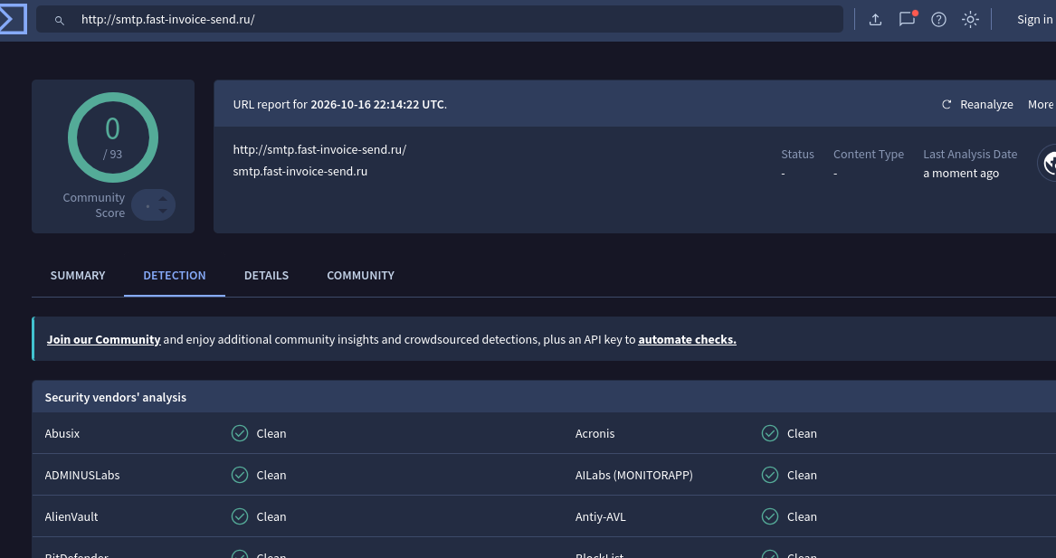
What it shows: http://smtp.fast-invoice-send.ru/ checked on 2026-10-16 22:14:22 UTC: 0 of 93 detections, community score 0, Status and Content Type blank, vendors (Abusix, Acronis, ADMINUSLabs, AILabs, AlienVault, Antiy-AVL and others) shown as Clean.
Figure B-02. AbuseIPDB: 194.165.16.101 summary card
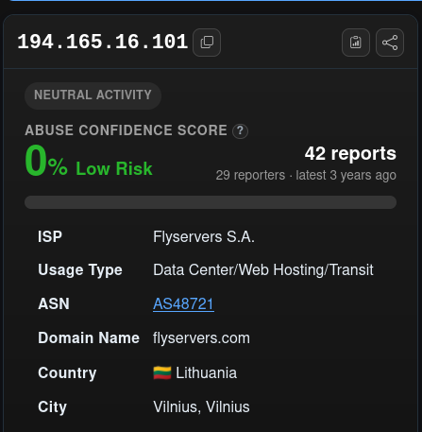
What it shows: 0% abuse confidence (Low Risk), 42 reports from 29 reporters, latest 3 years ago; Flyservers S.A., Data Center/Web Hosting/Transit, AS48721, flyservers.com, Lithuania (Vilnius).
Figure B-03. AbuseIPDB: 194.165.16.101 database entry
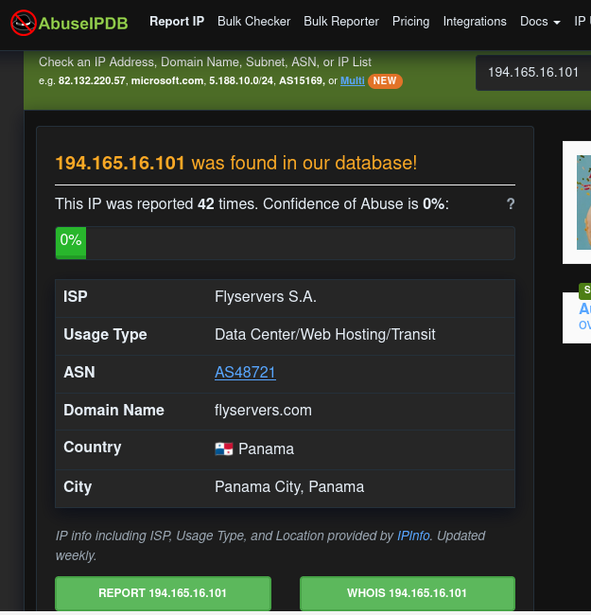
What it shows: The IP was reported 42 times with 0% confidence; same ISP and ASN, but the country is shown as Panama (Panama City), which conflicts with B-02.
Figure B-04. AbuseIPDB: no recent activity
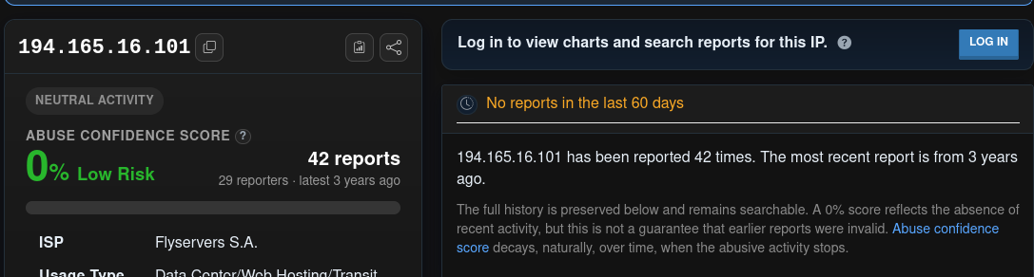
What it shows: Neutral activity, 42 reports, "No reports in the last 60 days", most recent report 3 years ago, with AbuseIPDB's note that a 0% score reflects the absence of recent activity.
Figure B-05. AbuseIPDB: report history for 194.165.16.101
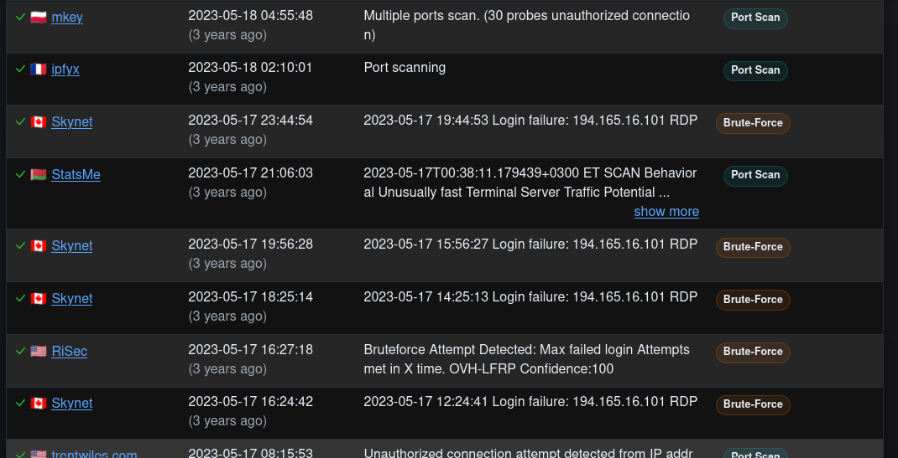
What it shows: Reports dated 17–18 May 2023: port scans and RDP login failures (brute force) from several reporters.
Figure B-06. AbuseIPDB: report history for 194.165.16.88
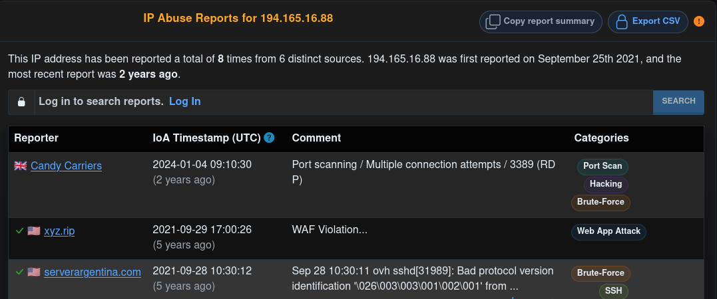
What it shows: 8 reports from 6 sources, first reported 25 September 2021, latest 4 January 2024: RDP port scanning (3389), a WAF violation and an SSH protocol probe.
Figure B-07. AbuseIPDB: 194.165.16.88 summary card
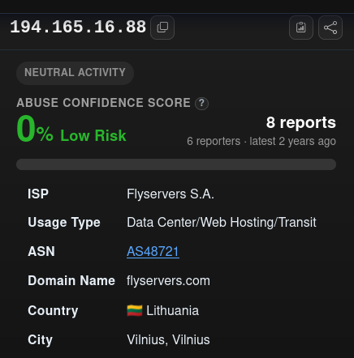
What it shows: 0% abuse confidence, 8 reports from 6 reporters, latest 2 years ago; Flyservers S.A., AS48721, Lithuania (Vilnius).
Figure B-08. AbuseIPDB: 10.0.0.14
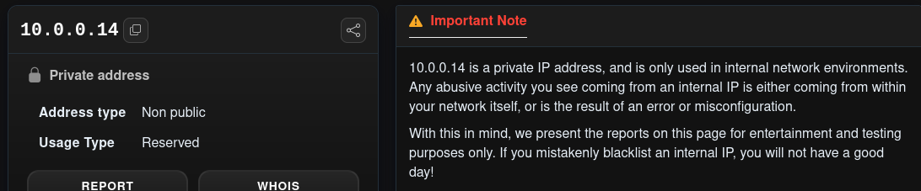
What it shows: Private, non-public, reserved address with a note that reports on such addresses are for testing only.
Figure B-09. AbuseIPDB: reports for 10.0.0.14
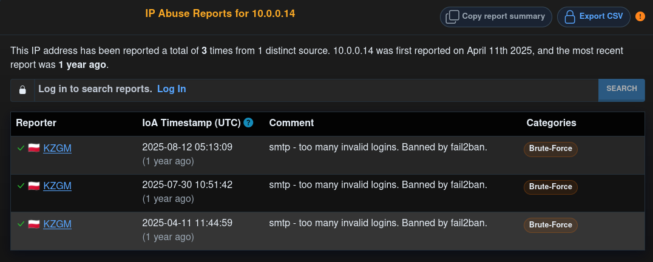
What it shows: Three reports from one source in 2025 ("smtp - too many invalid logins. Banned by fail2ban"). Not meaningful for a private address.
Figure B-10. Header fragment (appears to be Email 1)
What it shows: A cropped line "Received: from mail.mailer-srv-dispatch.xyz" under a Monday 14 April 2026 timestamp, which matches the Email 1 header chain.
Figure B-11. Mail/DNS diagnostic for mailer-srv-dispatch[.]xyz
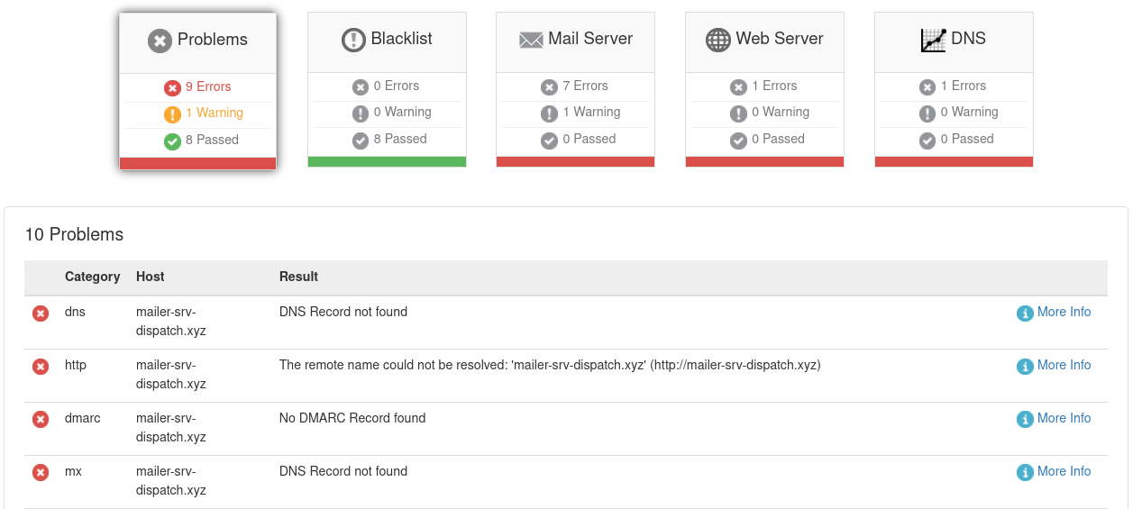
What it shows: 9 errors, 1 warning, 8 passed; DNS record not found, web name could not be resolved, no DMARC record, no MX record; blacklist checks 0 errors. Relates to Email 1.
Figure B-12. Browser PDF viewer error
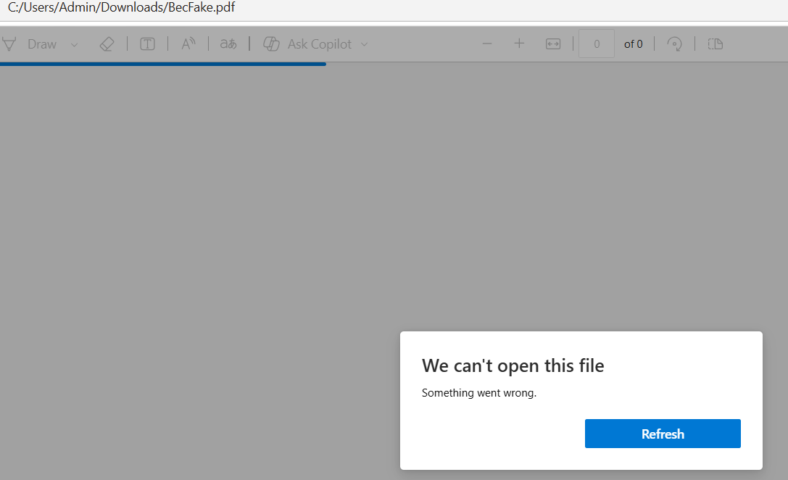
What it shows: C:/Users/Admin/Downloads/BecFake.pdf shows "We can't open this file. Something went wrong." The decoded file is a PNG, not a PDF.
Figure B-13. Original .eml: top headers
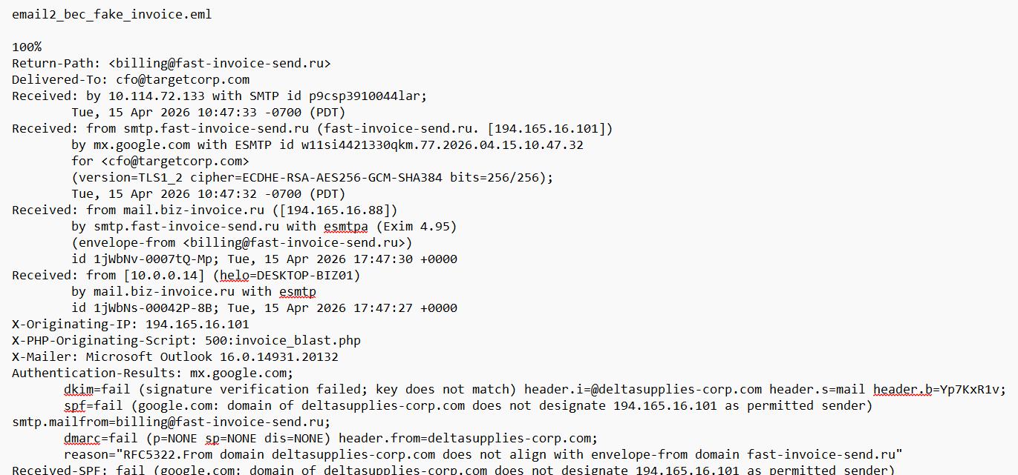
What it shows: email2_bec_fake_invoice.eml: Return-Path, Delivered-To cfo@targetcorp.com, four Received hops with timestamps, X-Originating-IP, X-PHP-Originating-Script, X-Mailer Outlook and Authentication-Results (DKIM, SPF, DMARC fail).
Figure B-14. Original .eml: DKIM signature and message headers
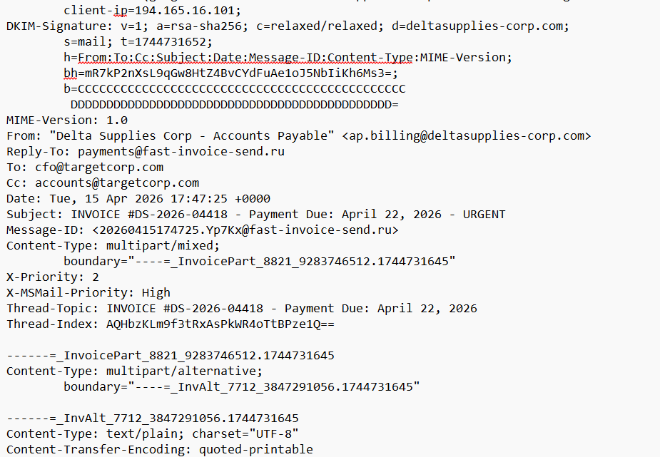
What it shows: DKIM-Signature (d=deltasupplies-corp.com, s=mail, t=1744731652, placeholder b= value), From, Reply-To, To, Cc, Date, Subject, Message-ID, boundary, priority and Thread headers.
Figure B-15. Original .eml: plain-text body
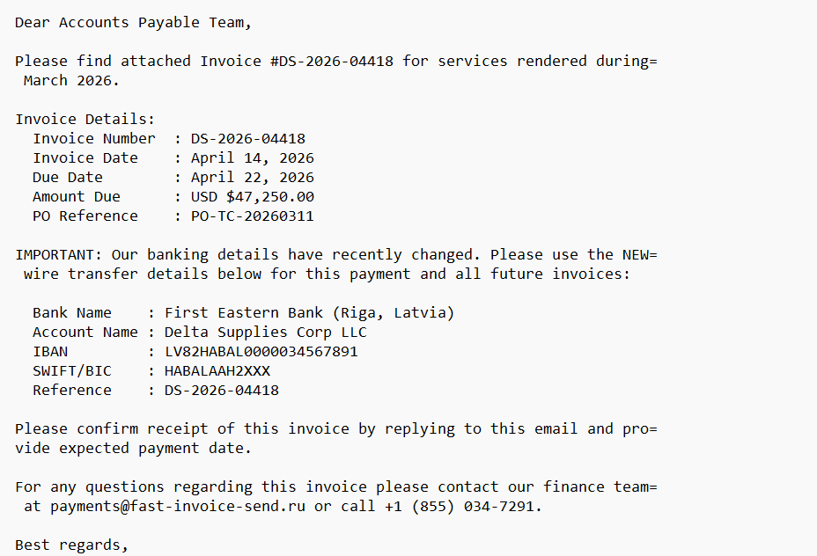
What it shows: Invoice details ($47,250.00 due 22 April 2026), the "banking details have recently changed" notice, Latvian bank details and the off-domain finance contact.
Figure B-16. Original .eml: signature and start of HTML part
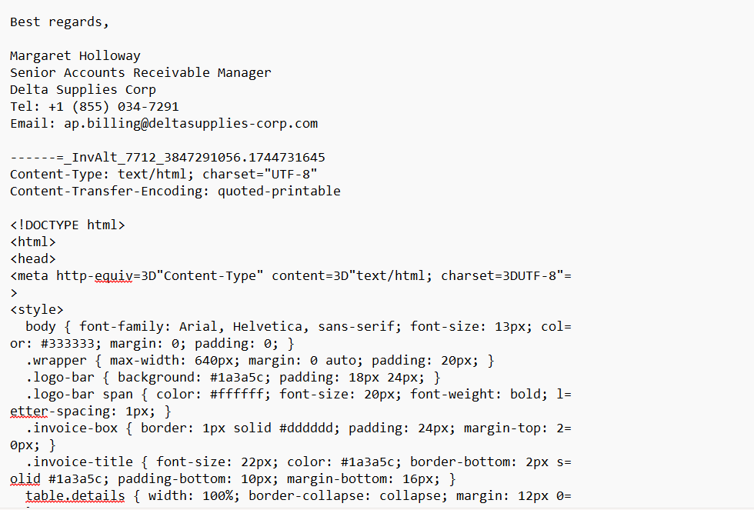
What it shows: Signature of Margaret Holloway, Senior Accounts Receivable Manager, and the start of the HTML part with its style block.
Figure B-17. Original .eml: HTML source (styles and invoice table)
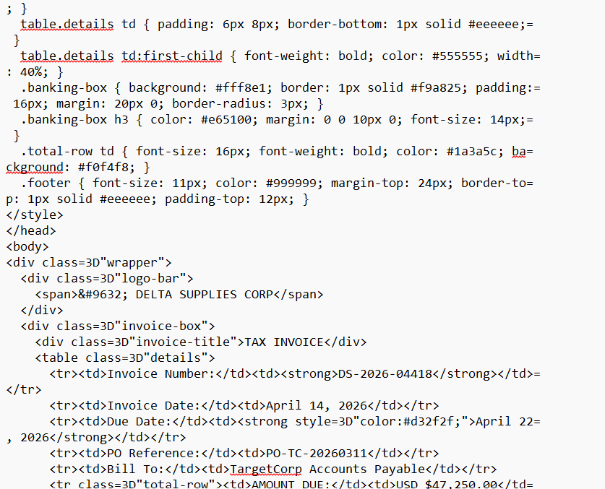
What it shows: Style rules, the "DELTA SUPPLIES CORP" logo bar, "TAX INVOICE" title and the invoice detail table (number, dates, PO, Bill To TargetCorp Accounts Payable, amount due).
Figure B-18. Original .eml: HTML banking box
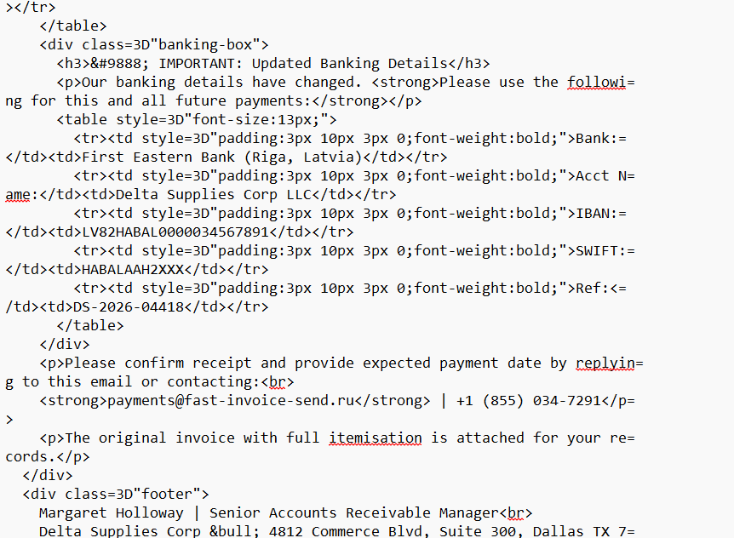
What it shows: "IMPORTANT: Updated Banking Details" box with bank, account name, IBAN, SWIFT and reference, the request to confirm payment date, and the note that the itemised invoice is attached.
Figure B-19. Original .eml: footer and PNG attachment part
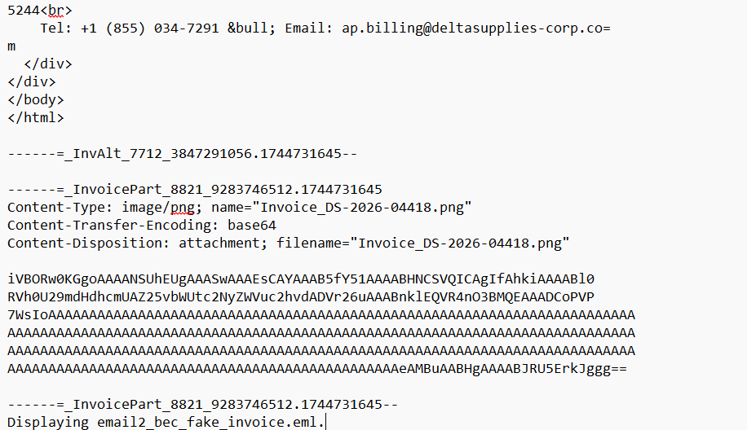
What it shows: Footer with the Dallas address and phone, then the image/png part Invoice_DS-2026-04418.png with base64 content (PNG header, a long run of "A" characters and an IEND ending).

End of SOC Investigation Report.

